THIRD SEMESTER SERIES TEST 1 ( October -2023)
ECT 283 ANALOG COMMUNICATION

Time: 1.5 hours Maximum Marks : 50

PART - A
Answer full questions, each carries 3 marks
Q.No. | QUESTION | MARKS | CO | LEVEL
1 | Explain the need for modulation | 3 | CO 1 | 1
2 | Explain flicker noise | 3 | CO 1 | 1
3 | Explain shot noise | 3 | CO 1 | 2
4 | Plot the signal x(t)=u(t+1)+2u(t)-u(t-3) | 3 | CO 2 | 2
5 | Find convolution of signal x[n] = [1,-1, 1, 1] with itself | 3 | CO 2 |  | 1
6 | Define unit step function and unit impulse function | 3 | CO 2 |  | 1
 | PART - B
 | Answer one question from each section. Each question carries 16 mark.
7 | (a) Explain Thermal noise in details (8 marks)  (b) Explain the elements of communication systems in detail? (8 marks) | 16 | CO 1 |  | 2
 | OR
8 | (a) Define the signal to noise ratio and noise and noise figure of a receiver? How noise temperature related to noise figure? (8 marks)  b)A mixer stage has a noise figure of 20 dB and this is proceeded by an amplifier that has a noise figure of 9 dB and an available power gain of 15 dB. Calculate overall nose figure (8 marks) | 16 | CO 1 |  | 2
9 | State and prove any 4 properties of FT | 16 | CO 2 |  | 1
 | OR | 16 | CO 2 |  | 1
10 | a Distinguish between energy & power signals. Give an example for each category? (8 marks)  b. (b) Explain shifting operation of the signal |  |  |  | 1

Course Outcomes
CO 1 | Explain various components of communication Systems
CO 2 | Explain various sources of noises and its effects in communication sytems

Levels - 1.Remember 2. Understand 3. Apply 4.Analyse 5. Evaluate 6.Create

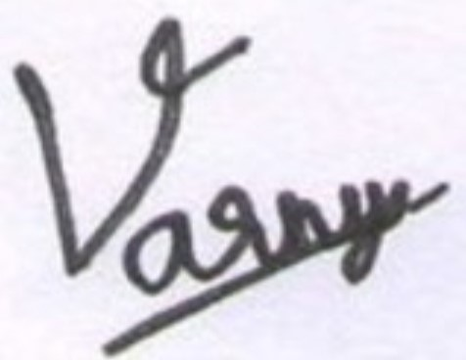
Signature of Faculty In charge Signature of Scrutiny Committee Member

EIGHTH SEMESTER SERIES TEST II (MAY 2023)
ECT 458 INTERNET OF THINGS

Time: 1.5 hours Maximum Marks : 50

PART - A
Answer full questions, each carries 3 marks
Q.No. | QUESTION | MARKS | CO | LEVEL
1 | Explain the need for IP optimization in IoTs? | 3 | CO 3 | 1
2 | What are the transmission modes used in Modbus? | 3 | CO 3 | 1
3 | Interface and control the status of an LED in GPIO 20 in Raspberry Pi | 3 | CO 3 | 2
4 | What are the 4 different cloud deployment models? | 3 | CO 4 | 2
5 | What is cloud computing | 3 | CO 4 |  | 1
6 | Draw and discuss the layered structure of the LoRaWAN network | 3 | CO 4 |  | 1
 | PART - B
 | Answer one question from each section. Each question carries 16 mark.
7 | Explain the differences between Narrowband-Internet of Things (NBIoT) and Long-Term Evolution for Machines (LTE M).  b.What are the modifications included in IEEE 802.15.4 e and g versions as compared to IEEE 802.15.4? | 16 | CO 3 |  | 2
 | OR
8 | With the help of a diagram explain the Zigbee protocol architecture. [8 ] (b) Explain LoraWAN architecture. Give a detailed description of the physical layer and MAC layer of LoraWAN | 16 | CO 3 |  | 2
9 | Explain different cloud service models ([12] (b) Explain cloud based data collection, storage and computing services provided by XIVELY cloud platform | 16 | CO 4 |  | 1
 | OR
10 | Explain different Raspberry-Pi Interfaces .Also, Explain NIMBITS cloud platform | 16 | CO 4 |  | 1

Course Outcomes
CO 3 | To understand the communication networks and protocols used in IoT. (K2)
CO 4 | To understand the cloud resources, data analysis and applications. (K3)

Levels - 1.Remember 2. Understand 3. Apply 4.Analyse 5. Evaluate 6.Create

Signature of Faculty In charge Signature of Scrutiny Committee Member

